Industrial Lab Safety Report

Hospital Based Robot – Testing

Date: | 22/02/2025
Student & SU nr: | YP Roets (25846299)
Student contact nr: | 073 836 2485
Supervisor: | Prof K Schreve
Lab engineer: | Mr Kevin Neaves
Head of safety: | Mr Cobus Zietsman

Emergency Contacts:

Contact: | Room nr. | Work nr. | Cell nr.
 |  | -
Mr C. Zietsman | M212 | 021 808 4275 | -
Campus Security | - | 021 808 2333 | WhatsApp:  082 808 233
Fire Brigade | - | 021 808 8888 | -
Ambulance | - | 021 883 3444 | -

Signatures:

Student:  (YP Roets) | 
Supervisor:  (Prof K Schreve) | 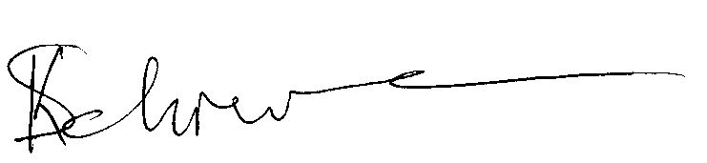
Lab Engineer:
(Mr Kevin Neaves)
Head of Safety:
(C Zietsman)

Pressure vessels or pipes (check relevant box):
☒ No pressure vessels or pipes with pressure in excess of 50kPa are involved in this project.
☐ Pressure vessels or pipes in excess of 50kPa are involved – additional signature and report required (refer to Safety Report Guidelines on SUNLearn).

Hot work / working at heights / confined entry / excavation (check relevant box):
☐ No hot work / working heights / confined entry / excavation work involved in this project.
☒ Hot work / working heights / confined entry / excavation work (underline relevant work type(s)) involved in this project – additional signature and report required (refer to Safety Report Guidelines on SUNLearn).
Overview of Testing

Type of test and standard (if applicable):

Test type | Testing of robot
Standard(s) | N/A

Equipment to be used:

Equipment type | Make & model | Measurement range (if applicable) | Resolution (if applicable)
Multimeter | Plusivo | 200 mV – 600 V,  0-10A | 1 mV,  1 mA
Soldering Iron | Plusivo | N/A | N/A
Raspberry Pi | Model 4B | N/A | N/A
Treaded Platform | LewanSoul Robot Tank Chassis | N/A | N/A
LIDAR Sensor | Okdo | N/A | N/A
Battery | Gens | N/A | N/A
Battery Charger | SkyRC Q200 NEO Charger | N/A | N/A

Detailed Experimental Procedure

The testing of the robot will involve many different aspects, including hardware, software and motion testing.
1. Electrical Testing
- Components Involved: Raspberry Pi 4 Model B, motor driver board, LIDAR, battery (8000 mAh), DC motors, and connectors.
- Procedure:
  - Use a multimeter to check voltage levels, continuity and resistance at various points.
  - Perform an initial power-on test while monitoring for any anomalies.
  - Test the charging and discharging of the battery.
2. Motion and Navigation Testing
- Components Involved: Treaded platform, geared DC motors, motor driver board, and LIDAR.
- Procedure:
  - Calibrate the LIDAR sensor to detect obstacles within the predefined safe distance.
  - Execute a manual control test to verify motor responsiveness before enabling autonomous navigation.
  - Run the robot on various surfaces to check traction and movement stability.
  - Perform obstacle avoidance and pathfinding trials, ensuring smooth and safe operation.
3. Gripping Mechanism Testing (if applicable)
- Procedure:
  - Test the robotic arm or gripping mechanism by picking up various objects (e.g., medication trays, small packages).
  - Evaluate force control to prevent crushing fragile items.
  - Check for potential hazards like finger entrapment or unstable load handling.
4. Environmental and Hospital Safety Testing
- Procedure:
  - Observe robot behaviour in a hospital-like environment, ensuring safe manoeuvring around people and equipment.
  - Simulate real-world scenarios, including tight corridors, elevators, and automatic doors.
  - Conduct tests during peak and off-peak hours to assess interaction with moving staff and patients.
  - Measure sound levels to ensure the robot does not cause unnecessary noise disturbances.

Warning Symbols

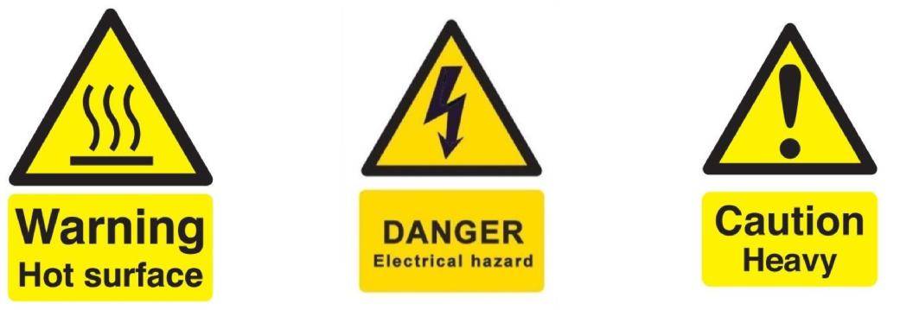

(a) Hot surface (b) Electrical hazard

Figure 1: Applicable warning/hazard symbols

General Laboratory Safety

The following general laboratory safety instructions are applicable:
- No afterhours testing may be performed without the necessary permissions.
- Full supervised training is required before testing may be undertaken. Permission to proceed with unsupervised testing should be signed off by the lab engineer.
- Closed shoes must be worn at all times.
- Emergency equipment must be located and easily accessible.
- Students may not work alone in the laboratory.
- Emergency exits must be known. The nearest exits applicable to the setup are provided in Appendix A of this document.
- Loose clothing may not be worn. Loose hair must be tied up.
- Good housekeeping practices should be maintained during testing. The lab should be completely clean, including all equipment stored away, after testing. Refer to the General Housekeeping section for particulars regarding practices to be followed for this specific setup.
- No food or drink is permitted in the laboratory.
- Safety report must be visible and accessible during testing.
- No equipment or test may be left unattended.

Anticipated Interactions with other Laboratory Users

- Shared Space Considerations:
  - The laboratory will be shared with other skripsie students and industrial engineering students.
  - The charging stations for the robots will be shared, with clearly allocated time slots to avoid conflicts.
  - Each student will have a designated locker to prevent mix-ups of components.
- Safety Precautions for Other Users:
  - A designated robot testing zone will be marked with danger tape to ensure non-participants stay clear.
  - Testing sessions will be scheduled to avoid interference with other experiments.
  - A warning system (either visual indicators or verbal announcements) will be used before testing starts.
- Communication and Awareness:
  - Other laboratory users will be briefed on the movements and potential hazards of the robot.
  - Lab supervisors will oversee test sessions to ensure adherence to safety protocols.

General Housekeeping

The following housekeeping steps must be taken:
- Return any tools to their respective places in the labs after use.
- Ensure workspace is clear and clean.
- Report any damaged or broken components, tools or machinery.
- Ensure all equipment and computers are turned off properly before leaving the laboratory.
- Ensure all plug points are turned off.

Fire Safety

- Potential Fire Hazards:
  - Lithium Polymer (LiPo) Battery: Overheating or improper charging could result in a fire.
  - Soldering Iron: High temperatures pose a burn and fire risk.
- Preventative Measures:
  - Battery Safety:
    - Store batteries in fireproof containers when not in use.
    - Use manufacturer-recommended chargers and avoid overcharging.
    - Never charge batteries unattended.
  - Soldering Safety:
    - Always use a heat-resistant mat during soldering.
    - Keep flammable materials (e.g., paper, alcohol-based solutions) away from the soldering station.
    - Allow the soldering iron to cool down completely before storage.
  - General Fire Safety:
    - Keep a CO2 or dry chemical fire extinguisher within reach.
    - Ensure fire exits are unobstructed and known to all lab users.
    - In case of fire, follow emergency evacuation protocols as outlined in Appendix A.

Activity Based Risk Assessment

Activity | Risk | Risk Type* (P/E) | Mitigating Steps | Classification of Risk Severity
Entering the lab | Tripping over cables, collisions | P | Keep area clear, avoid distractions | Low
Electrical Testing | Shock, short circuits, component failure | E | Use insulated tools, follow correct wiring procedures | Medium
Soldering Components | Burns, inhalation of fumes | P | Use a fume extractor, handle iron carefully | Medium
Robot Movement Testing | Pinched fingers, entrapment, collisions | P | Keep hands clear, mark the testing area, warn others before tests | Medium
LIDAR Operation | Laser exposure risk | P | Avoid direct eye exposure to laser emissions | Low
Battery Charging and usage | Fire hazard, explosion risk | E | Use manufacturer-approved chargers, store batteries in fireproof containers | High
Manual Handling of Robot | Strains, lifting injuries | P | Use proper lifting techniques, get assistance for heavy parts | Medium
Navigation Testing in Lab | Unexpected movement causing collisions | P | Use controlled movements, have an emergency stop function | Medium
Gripper Function Testing | Finger entrapment | P | Use protective gloves, test with non-living objects first | Medium
Data Collection | Software glitches, incorrect readings | E | Regular calibration, double-check readings | Low
Emergency Power off | Power loss leading to data corruption | P | Save data frequently, ensure backup power is available | Medium
*P – personal, E - equipment

Disciplinary Actions
Failure to comply with any of the aforementioned safety regulations or procedures will result in disciplinary action. Students will be issued an initial warning: after three warnings, the lab access is revoked for a month.

Appendix A: Emergency Evacuation Plans [eg: Structures lab and surrounding laboratories]

[Circle applicable exits and fire extinguisher locations]

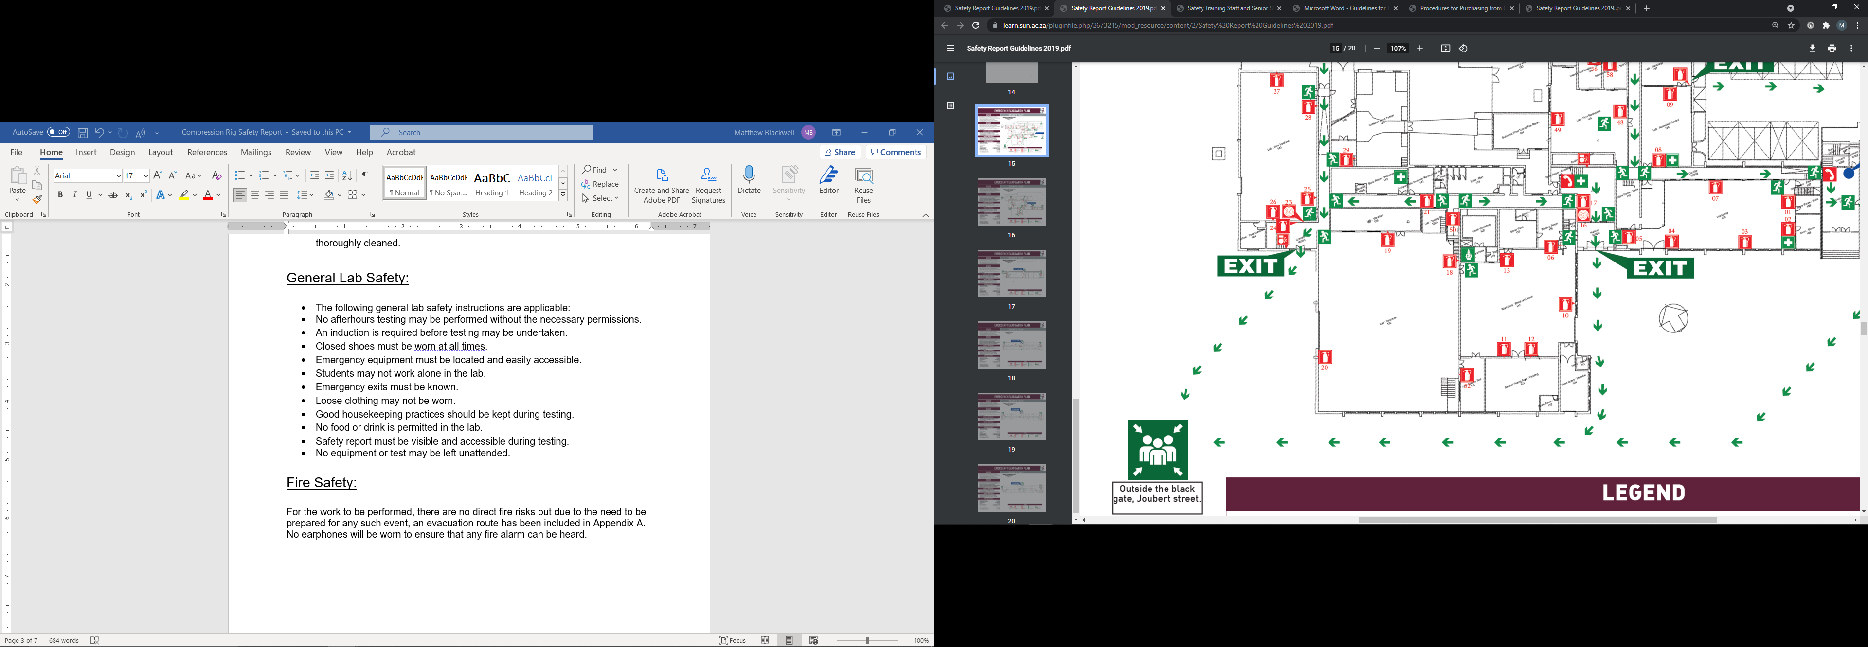

Written permission from supervisor and approved by the chief safety officer. Attach proof of this permission to this document and note here the times and conditions of the arrangement.

